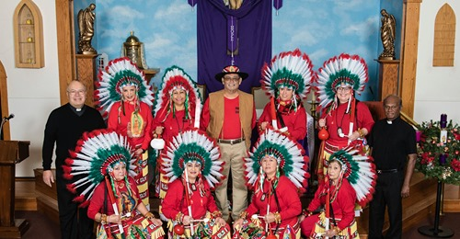
Danza “Guadalup” Ministry
Our Lady of Peace Catholic Church

Dear Sirs:

The Danza “Guadalup” Matachines Ministry at Our Lady of Peace Catholic Church is a religious non-profit organization that serves the Parish and the Great Alpine Community. Danza “Guadalup” organizes activities to affirm “love for God”, to “honor Jesus Christ” and to promote “Good Will” among neighbors.

Our goal is to raise community support for planning an “Alpine Multicultural Festival” to be held at Kokernot Park on June 11-12, 2022. The weekend family-oriented event will focus on multicultural cultural music/dance entertainment, educational art and crafts displays, food booths and games for children. Matachines, Country Western, and Mexican/American Ballet groups will be invited to participate.

This is a free public event. We need the support of your business as an official sponsor. We humbly ask for a donation of $100 or more. Please make checks to Matachines Danza Guadalupe and mail to Attn: Ruth Macias, PO Box 354, Alpine, Texas 79831. We also accept alternative means of assistance. In return, we will promote your business extensively during the event. A festival T-shirt will be awarded to you as a token of our appreciation.

The event will be promoted, within and beyond, the tri-county area to attract visitors to the Alpine vicinity. Out of town visitors will stay at local hotels, dine out at local restaurants, and make purchases in town. This event will make Alpine a weekend destination.

Please call any of the event organizers listed below to pledge your donation. We look forward to your supportive and speedy response.

Sincerely,
Eva Olivas (432-386-3950); Ruth Macias (432-294-0553); Dayami Fernández (432-294-2804)

